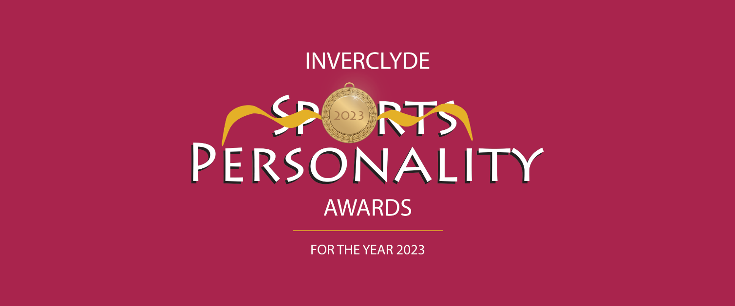

SPORTS PERSONALITY NOMINATION FORM FOR SENIOR, JUNIOR, DISABLED,

TEAM, SCHOOL TEAM AND CLUB CATEGORIES

Please complete and submit this form online with a head and shoulders and also an action picture of the nominee or download it and complete it by hand and send it with the pictures to Chris Jewell, Inverclyde Sports Personality Awards, 43A Esplanade, Greenock PA16 7RY to arrive by Monday 26TH February 2024. It can also be downloaded, completed and scanned in and emailed to ispagreenock@gmail.com.

In respect of the Coach of the Year and the Junior and Adult Volunteer Awards there is a separate Nomination form which is also found on our website. Please complete that form for those categories ONLY and submit it or post it with photographs.

An important element of the individual Sports Personality Awards (Senior, Junior and Disabled) is what the nominee has done over the year to promote his/her sport. Please make
sure you cover this aspect well in your nomination.

Conditions

1) Candidates for awards must be resident in Inverclyde and / or competing for an
Inverclyde based club.

2) For Coach of the Year, Young Volunteer of the Year and Adult Volunteer of the Year
please complete the nomination form also available on the website.

3) ‘Junior’ usually means under 18 years of age; however it is appreciated that in some sports a person may be allowed to compete as a junior at an older age. This will not exclude such nominees from being considered as juniors.

4) A person may be nominated for an individual award and be a member of a team/club which has been nominated for the team/club award.

5) Judging of nominations in all categories will be carried out by a specially selected panel. All decisions of the selection panel will be final.

NOMINEE FOR AN AWARD

Name

Age as at 31 Dec 2023

Address

Post Code

Daytime Tel. No.

Mobile Tel No.

Email address

Sport

Club

Governing Body

PERSON MAKING THE NOMINATION

Name

Address

Post Code

Email address

Daytime Tel No.

Mobile Tel No.

Date submitted

CATEGORY OF AWARD (tick all being nominated for)

Senior Sports Personality of the Year
Junior Sports Personality of the Year
Disabled Sports Personality of the Year
Team of the Year
School Team of the Year
Club of the Year

www.inverclydesportspersonality.com

AWARDS AND ACHIEVEMENTS ATTAINED DURING 2023

At local level
usually means under 18 years of age; however, it is appreciated that in some sports a
person may be allowed to compete as a junior at an older age. This will not exclude such
nominees from being considered as juniors.

At national level

At international level

Name of Nominator

Email address of nominator

Contact Tel no. of nominator

Date

